Metrics ion classification pblms:
1.confusion matrics
2. FPR (type 1 error)
3.FNR (type 2 error)
4.Recall
5.Precision
6.Accuracy
7.F Beta
8.Choen Kappa
9.ROC Cureve,AUC Curve
10.PR Curve

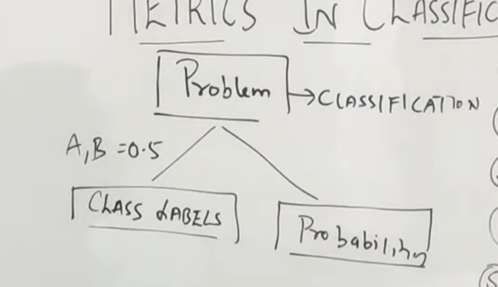

If I have 1000 records with 500 yes and 500 no or 600 yes and 400 no or 700 yes and 300 no its fine
But 80 to 20 ratio is not fine . which is a unstable data

Confusion matrix :
It’s a 2*2 matrix
Which has true +ve , false +ve , false -ve , true -ve
False +ve is a typr 1 error.
False -ve is a type 2 error.
Since these are balanced data we can directly calculate the accuracy = 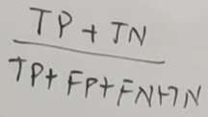
If the data is not balanced it will not be perfectly not trained . were we cant measure the accuracy , were we use some other metrics .
We should always try to reduce the type 1 and 2 errors .
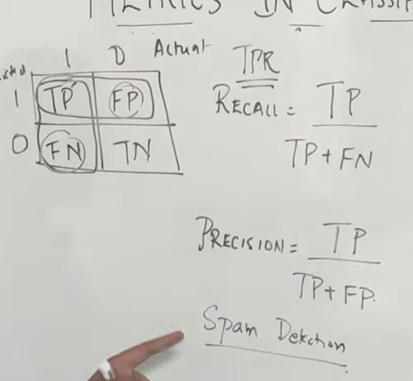
When the false +ve is more important use precision.
When the false -ve is more important use recall.

F- beta square
